**Title (Bold, centered, single spacing, Verdana 14pt)**

Author1, 1 Author 2,2  Author,3 ... (Initial. Last name, Verdana 10, centered)

Full address ( centered, Verdana, 9)

Corresponding author, email address (centered, Verdana, 9)

Follow this text format to submit your abstract, maximum one page, 1.5 spacing, Verdana 10 font, with left, top, and bottom margins of 2.5 cm and a right margin of 3.0 cm. You may include tables and/or figures in high quality. Send the abstract to the email address [iscsn2025@gmail.com](mailto:iscsn2025@gmail.com).

**Only one page is allowed**

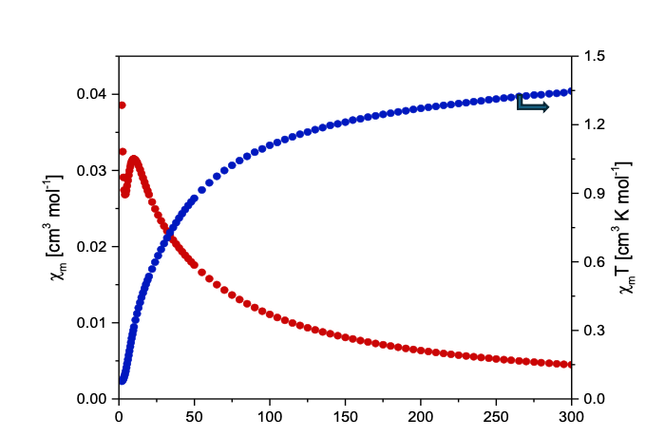

**Figure 1.** Magnetic Suscebtibility and magnetic susceptibility by temperature product as a function of temperature curves. **(Verdana 9)**

**Reference (Verdana 9)**

[1] Initial(s). Last name 1, Initial(s). Last name2, … (Verdana 9), *Journal*, **2017**, *5*, 01-07.

**Acknowledgements (Verdana 9)**

(Verdana 9)